TASKS ON IAM (Identity Access Management)

1. Create one IAM user and assign EC2 and S3 full access roles.

PURPOSE: To provide a dedicated user with the necessary permissions to manage and operate both Amazon EC2 and Amazon S3 services securely without using AWS root account.

OBJECTIVE: The objective is to create a dedicated aws user and grant the necessary permissions to manage Amazon EC2 and S3 services, enabling secure and controlled access to cloud resources.

OUTCOME: A dedicated IAM user is able to independently administer Amazon EC2 and Amazon S3 resources with full access permissions while maintaining secure and controlled AWS account access.

PREREQUISITES: You have an AWS account with sufficient administrative privileges to create IAM users and assign EC2 and S3 full access permissions.

STEP BY STEP IMPLEMENTATION:
- Firstly create a user with the EC2 and S3 full access.
- For the access, we have to attach policies that relates to full access to EC2 and S3.
- Then click on create user it will create a user with the user name, account id and password.

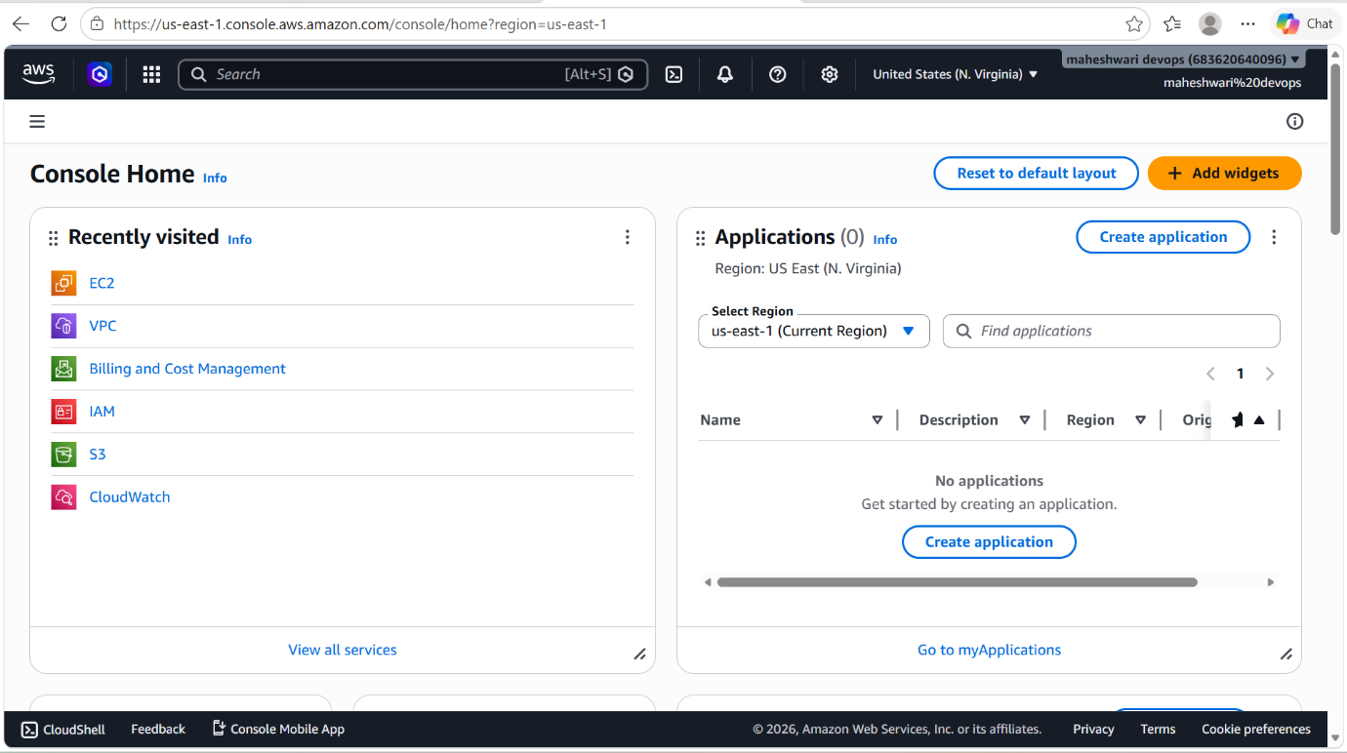



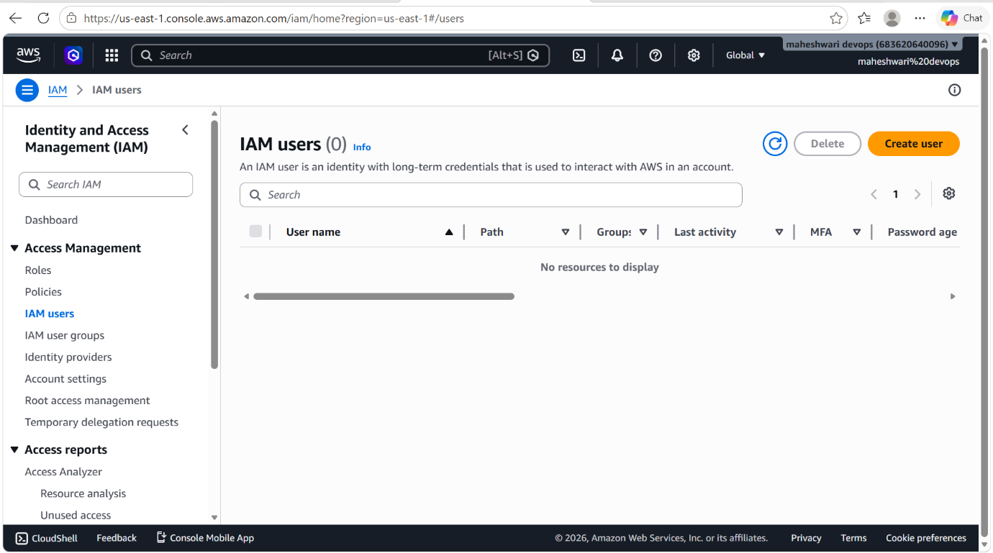

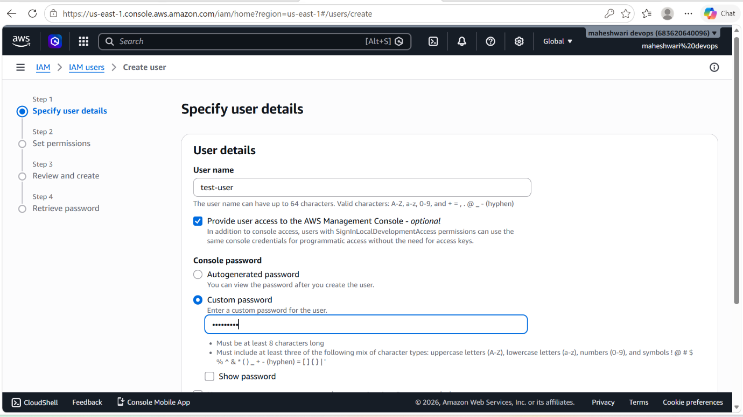

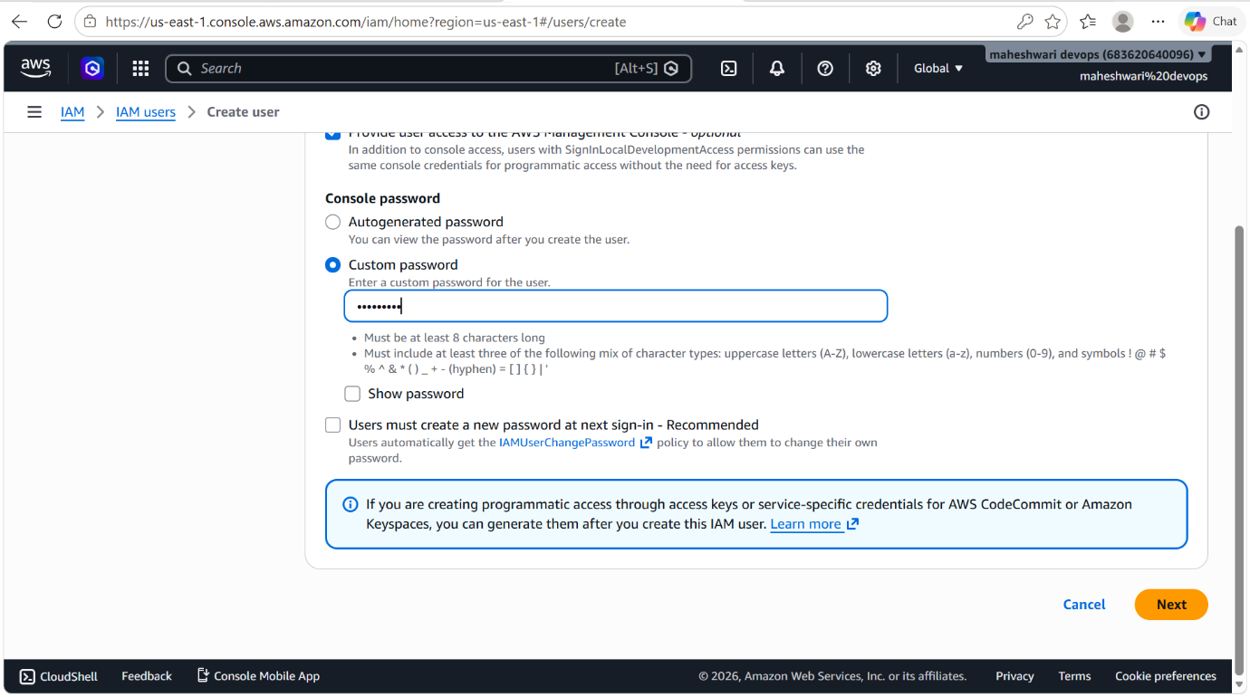

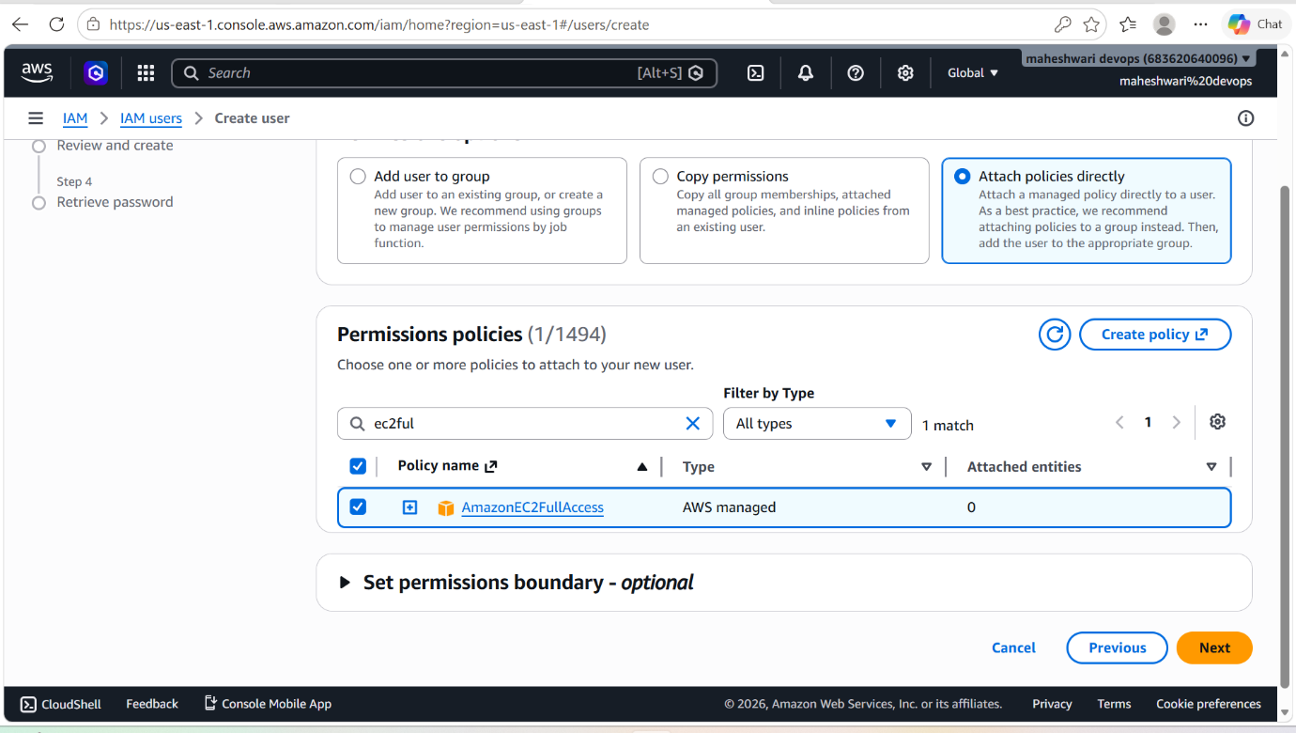

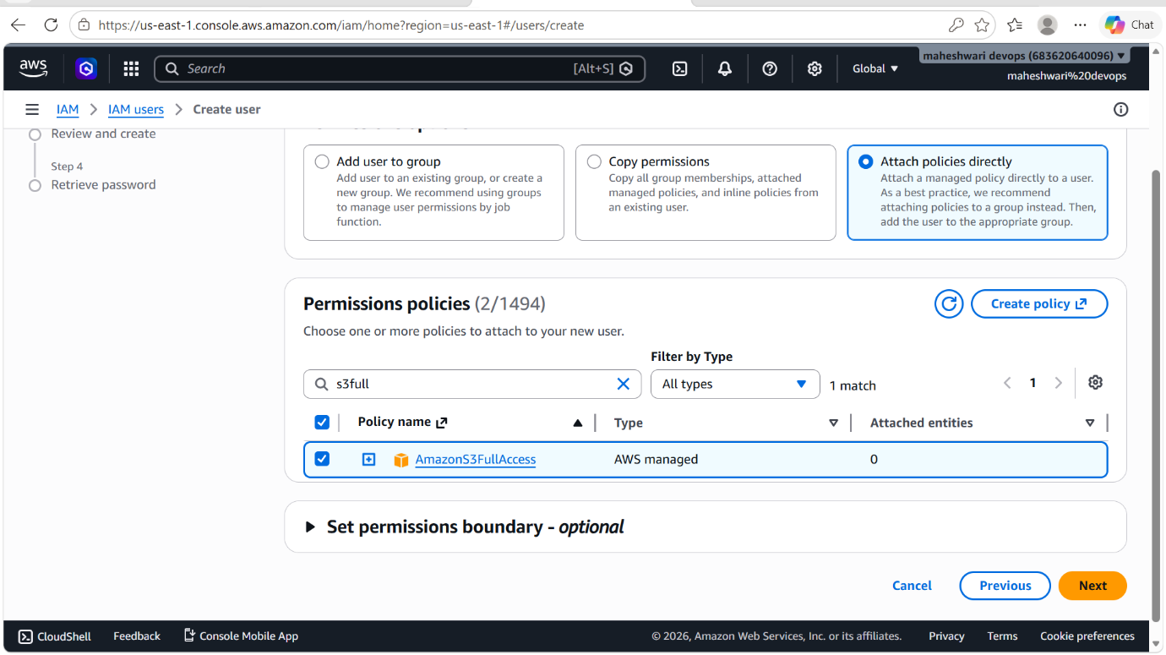

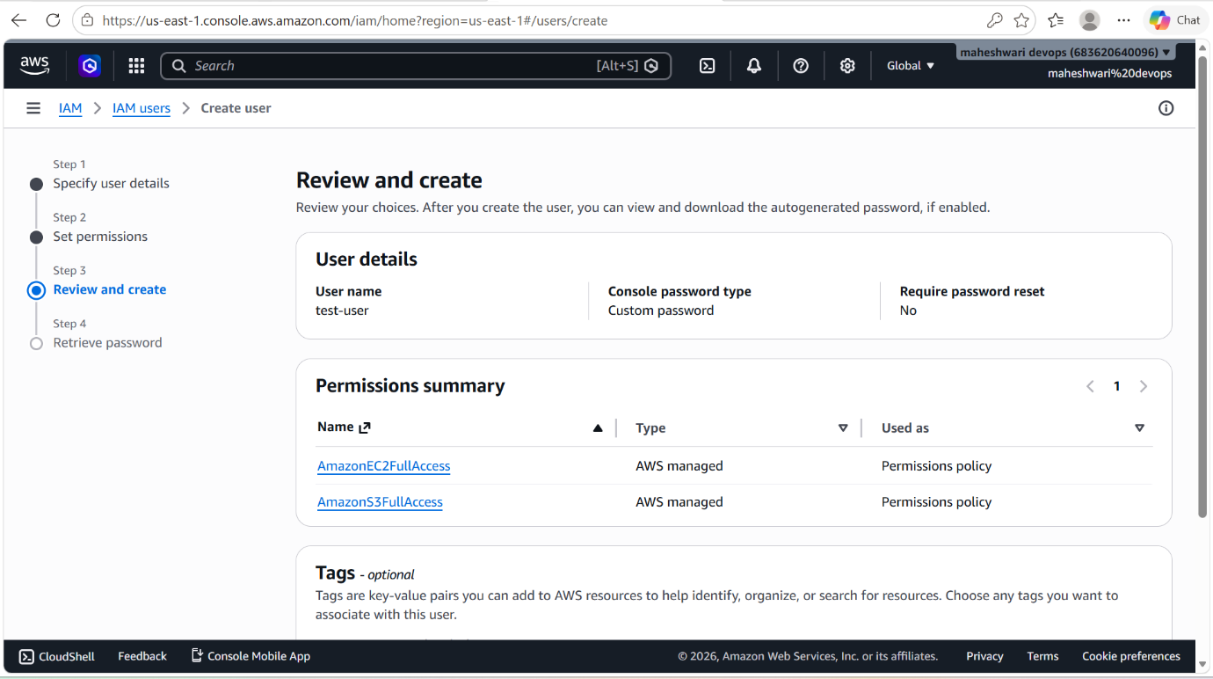

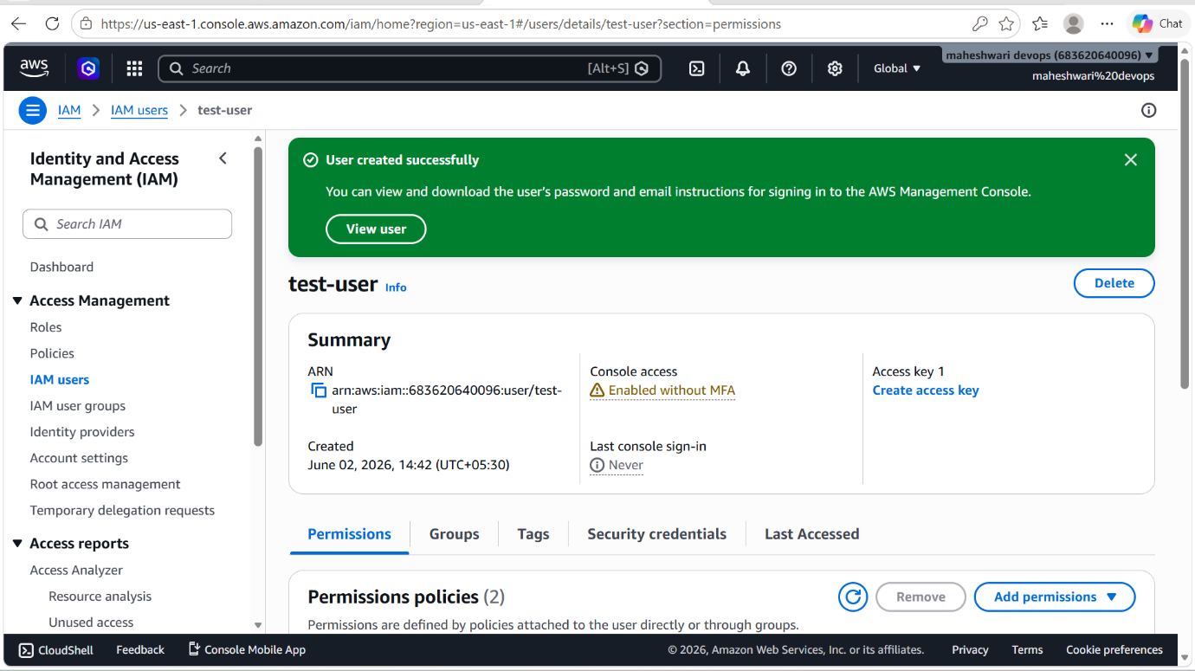

- Now login into the aws console with user details that we have created.

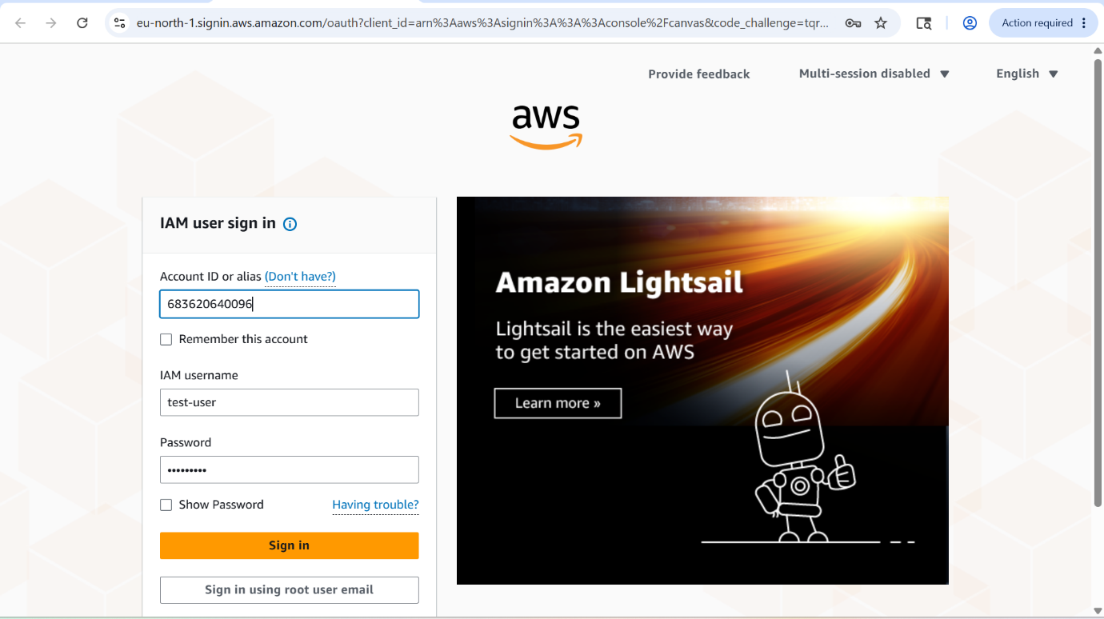

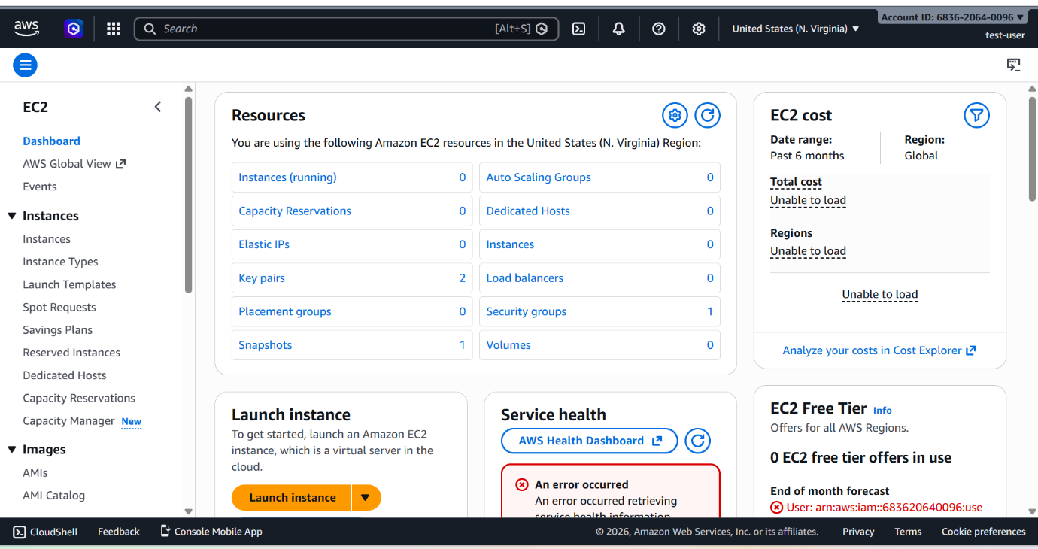

- Now verify the policies that we have attached are correctly working.
- For that, create a S3 bucket.
- And then launch an ec2 instance and ssh into that instance with the pem key.
- And there use the command aws s3 ls, if the CLI will ask for configuration.
- Then use the command aws configure, with aws access id and secret access key, region and format.
- After configuration, now again execute the command aws s3 ls
- Now it will show the buckets that present in your S3 service.

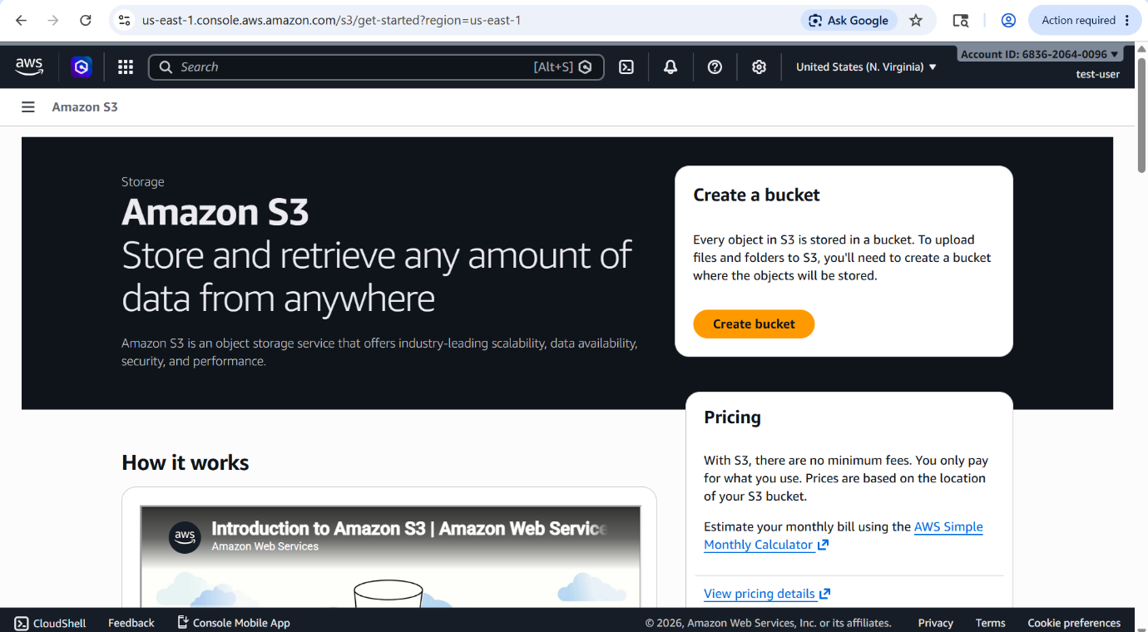

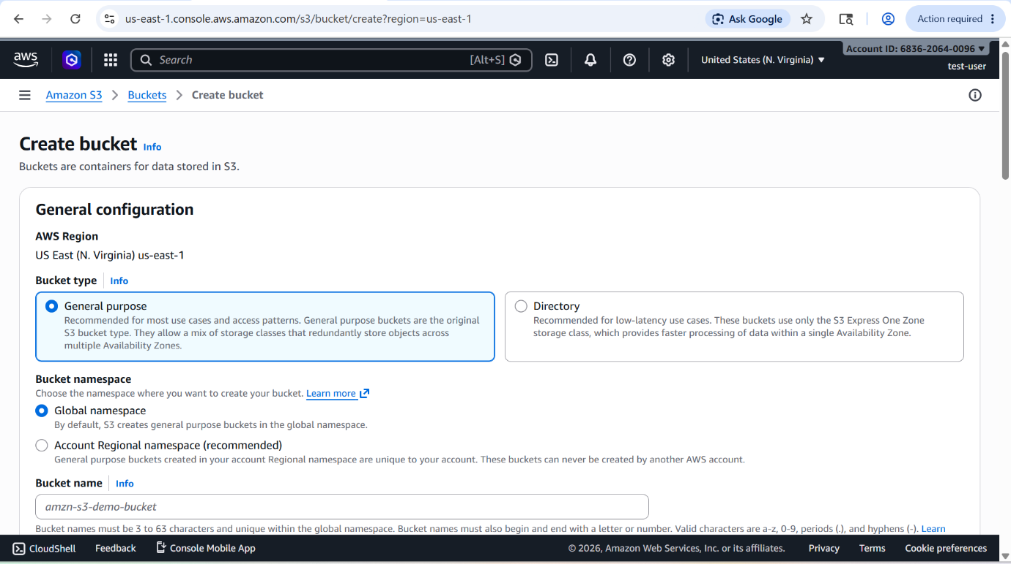

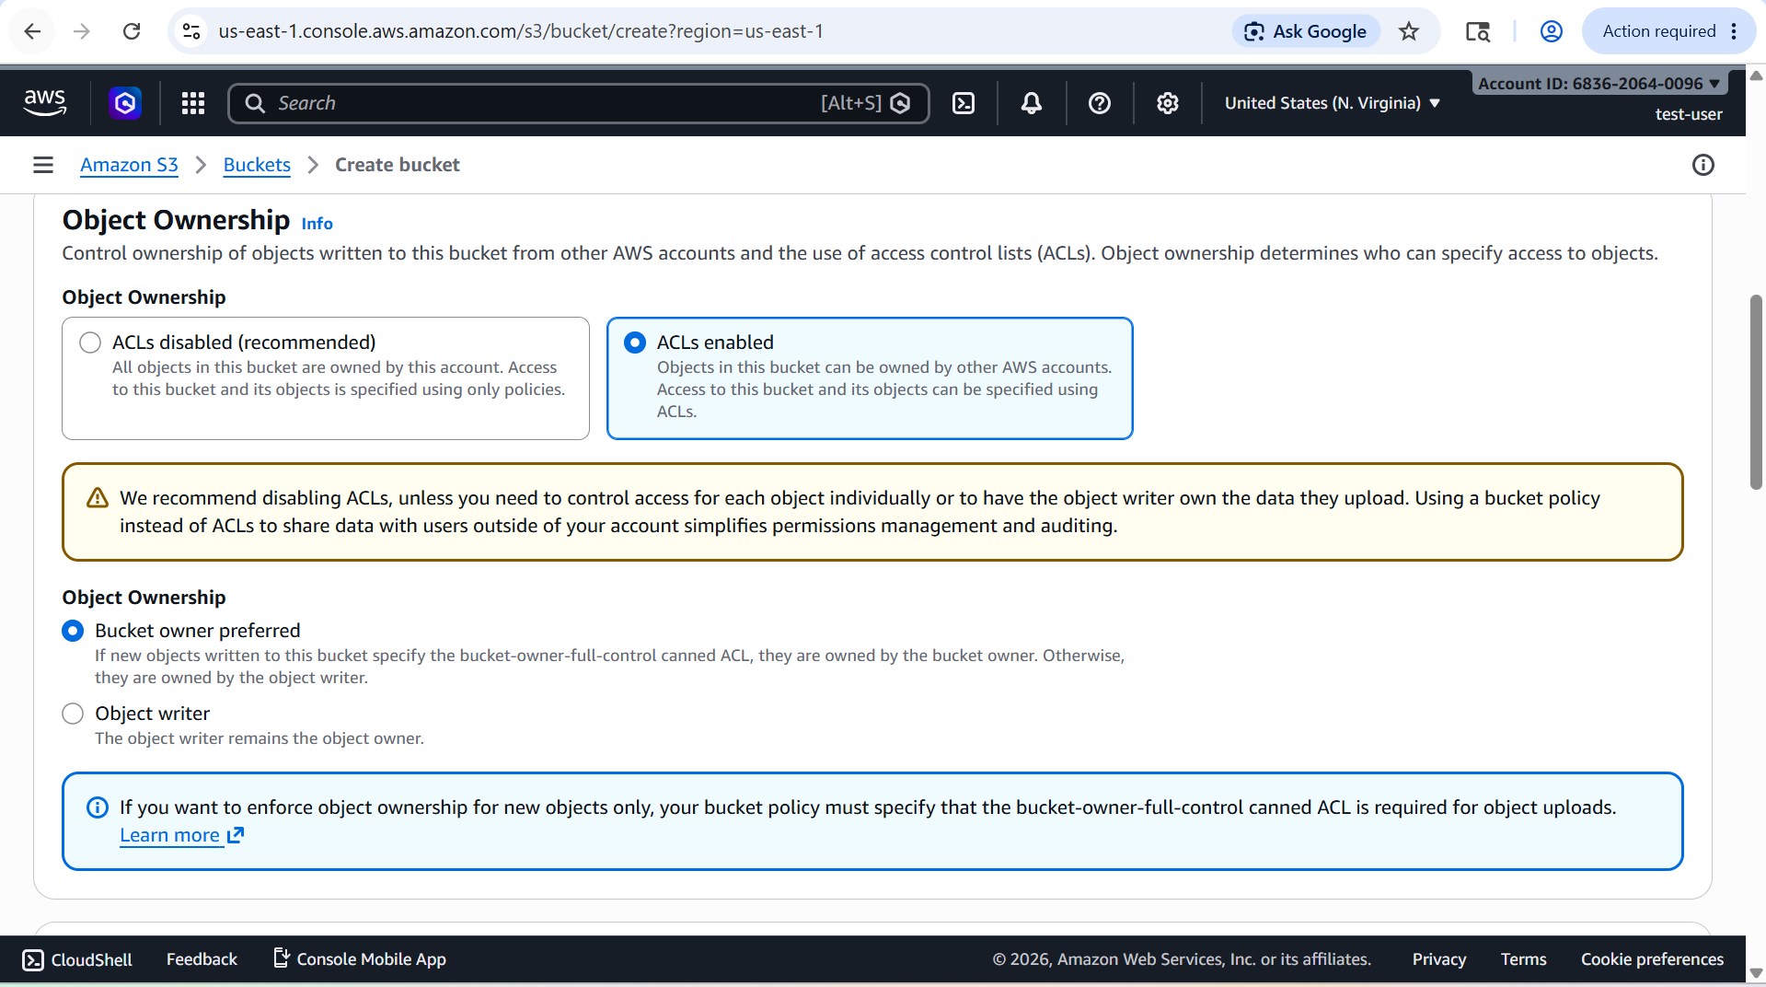

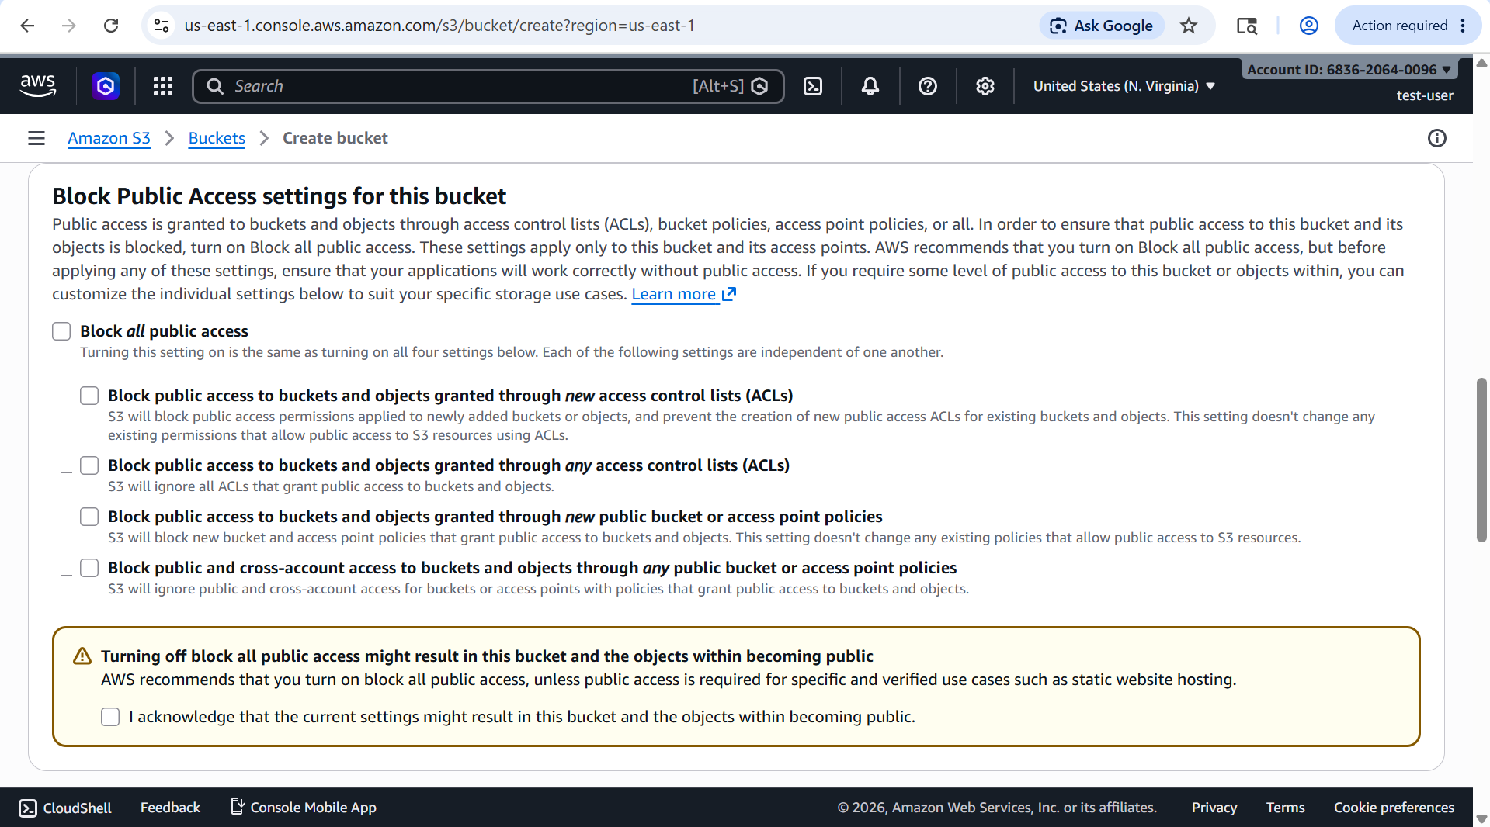

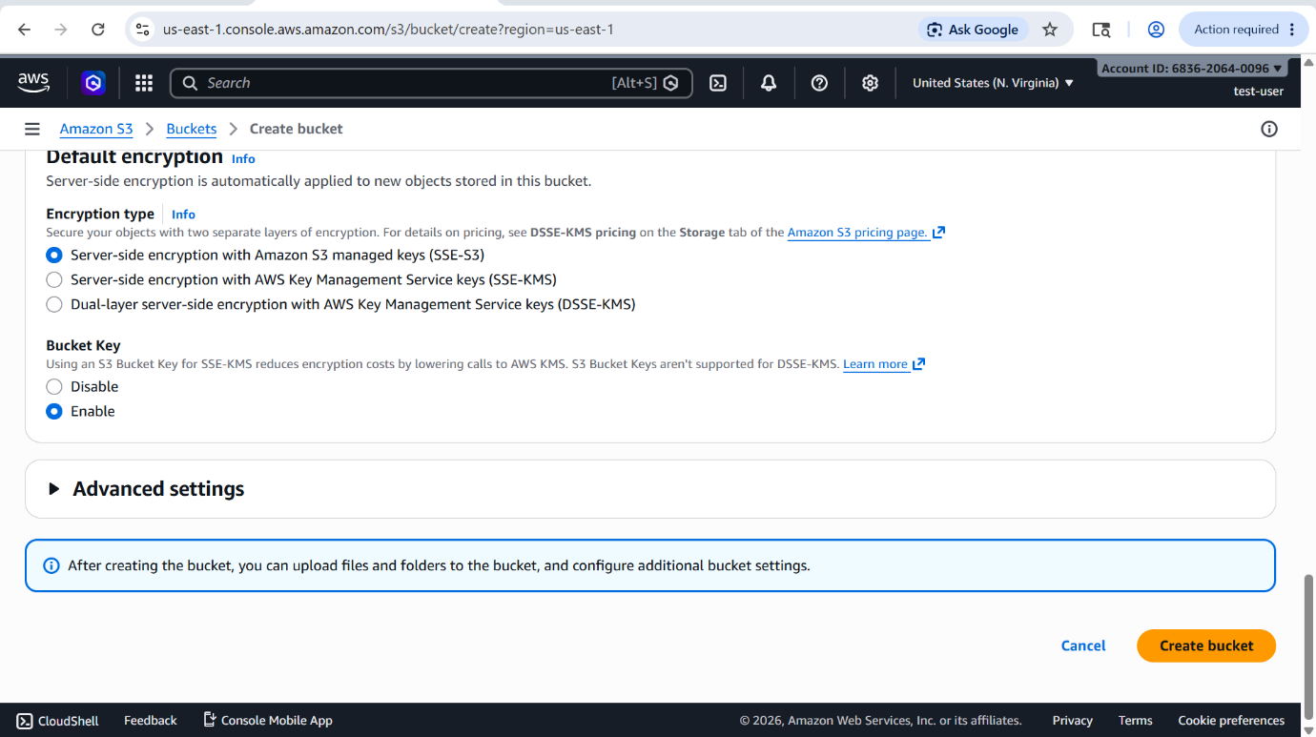

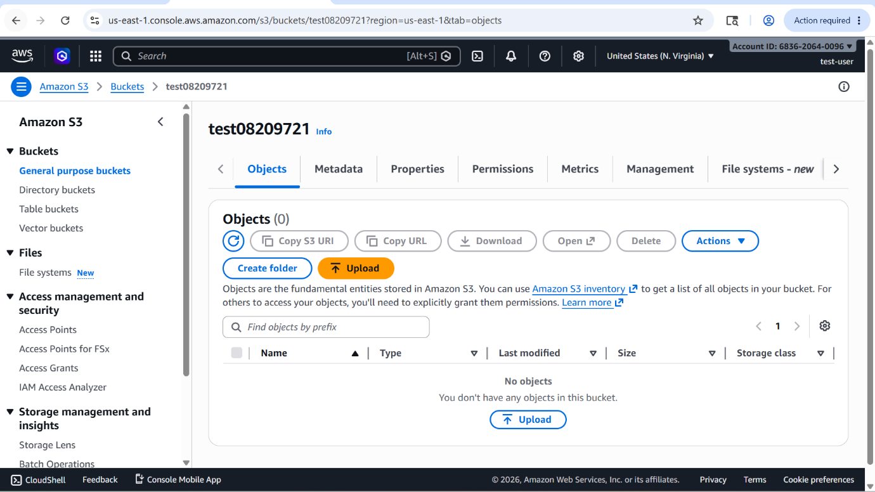

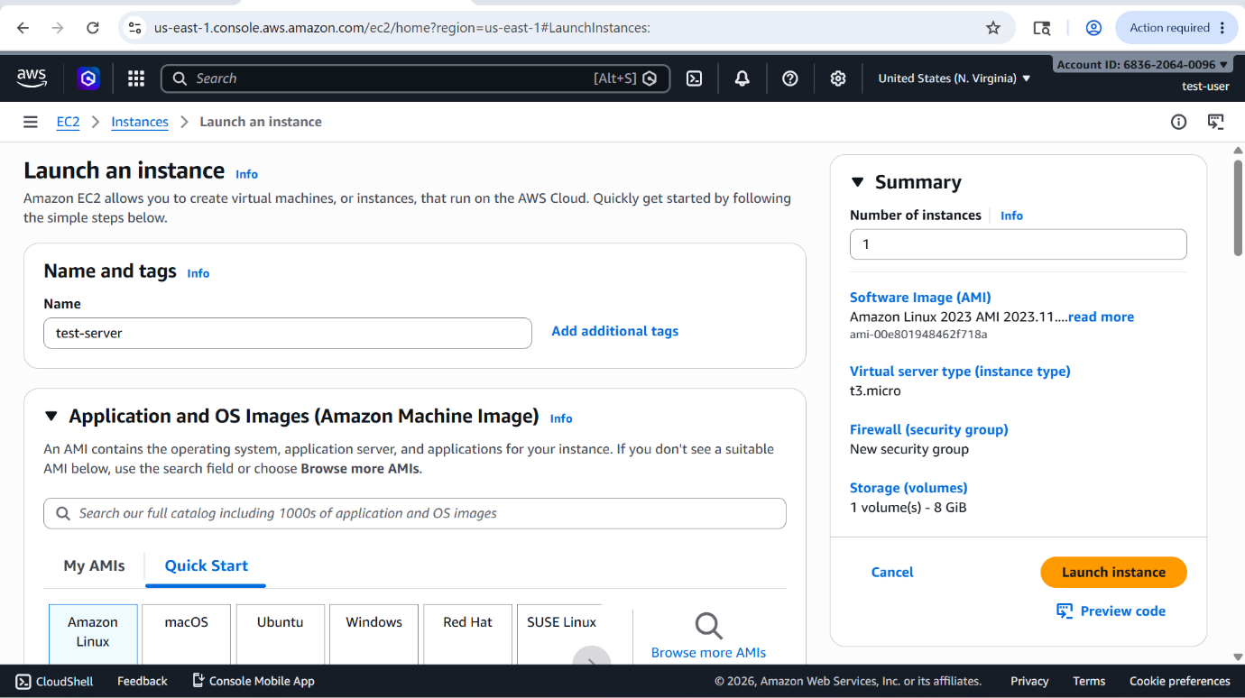

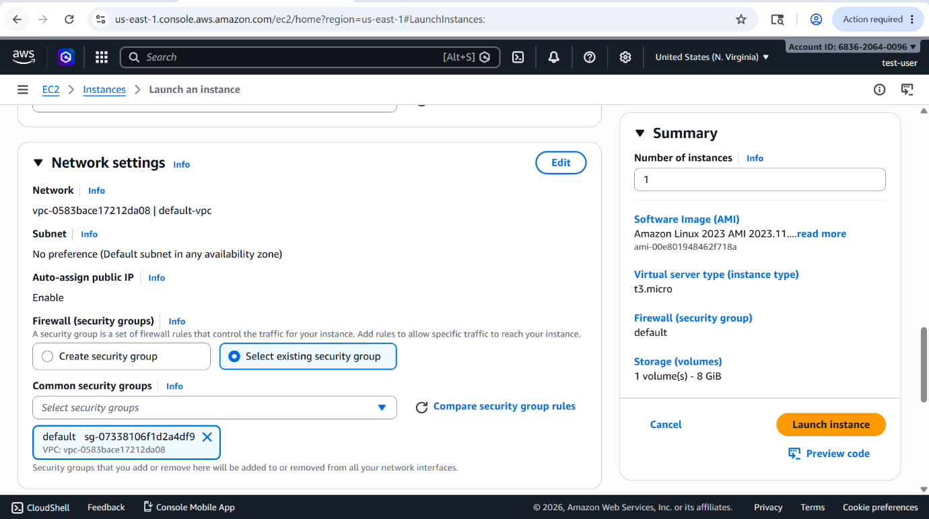

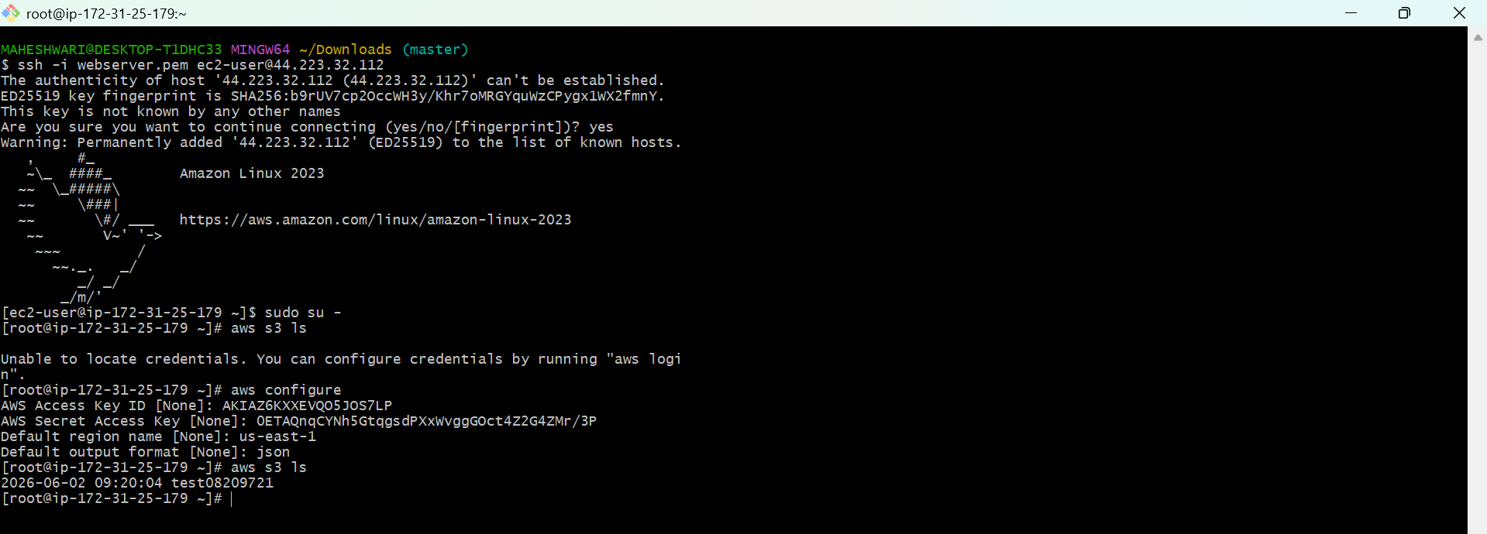

2. Create one group in IAM and assign read access for EC2.

PURPOSE: The purpose is to simplify permission management by creating an IAM group that provides read-only access to Amazon EC2 resources for multiple users who need to monitor or view EC2 configurations without making any changes.

OBJECTIVE: The objective is to implement role-based access control by creating an IAM group and granting it read-only permissions to Amazon EC2 resources, allowing users to view EC2 information without modifying any resources.

OUTCOME: A centralized IAM group provides secure, read-only access to Amazon EC2 resources, enabling users to monitor and review infrastructure while preventing unauthorized modifications.

STEP BY STEP IMPLEMENTATION:
- Firstly go to the IAM service in AWS.
- Then in IAM service search for the user groups in the navigation pane.
- In that page, click on create group.
- Give the group name and attach the policies that required, in our case I want to give EC2 read access only.
- So search for that policy and attach that policy to the group.
- Then click on create group and it will create a user group for us.

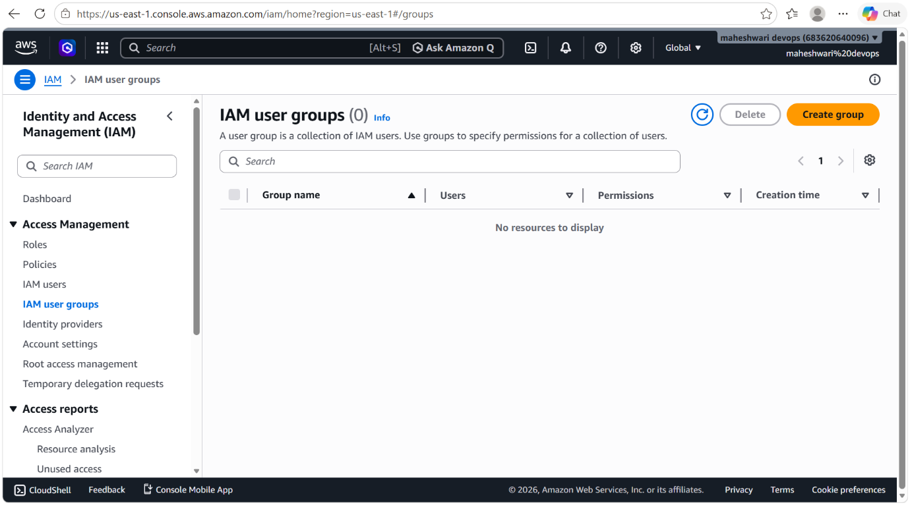

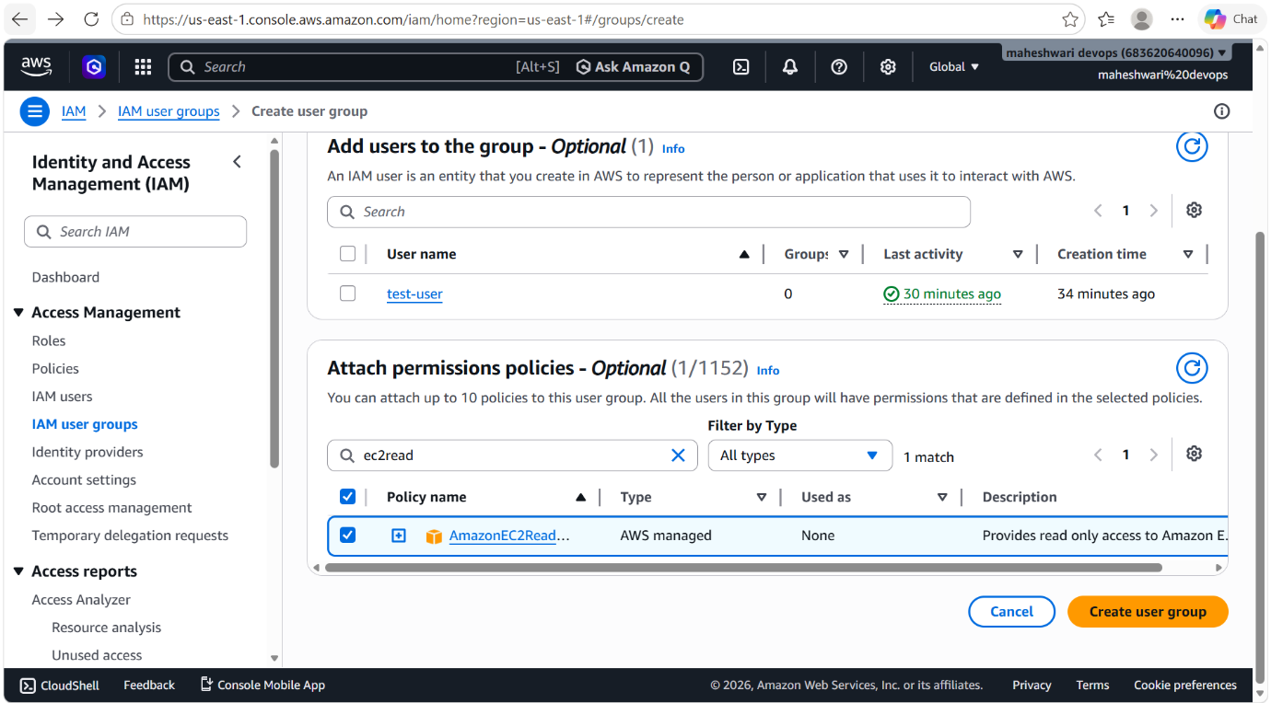

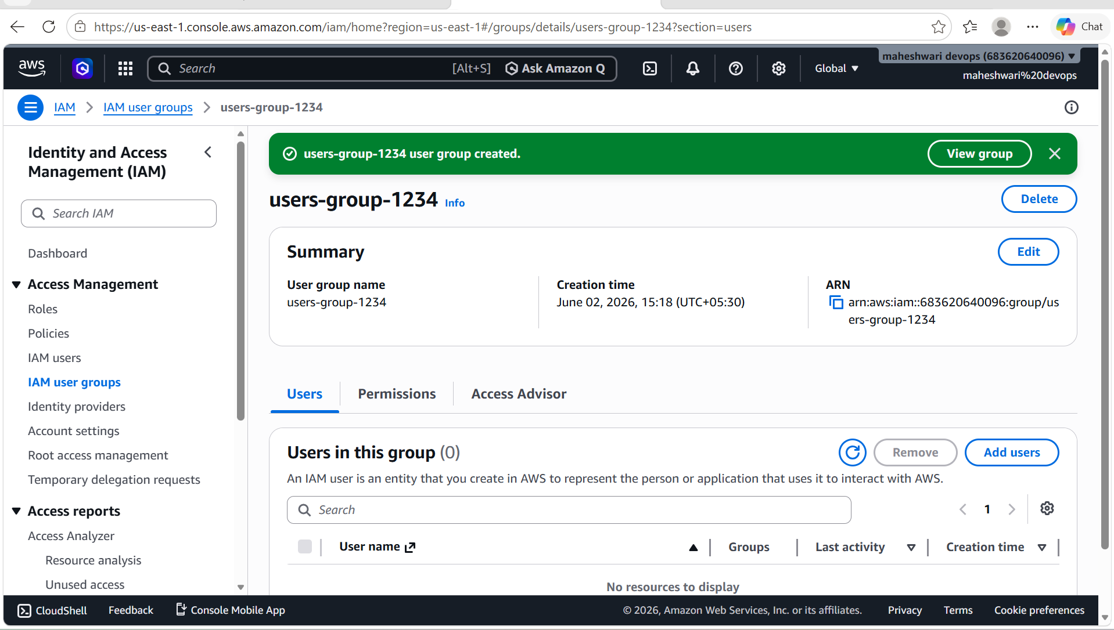

3. Create a new user named "Devops" and add to the group created in task 2.

PURPOSE: The purpose is to provide the Devops user with the permissions already assigned to the IAM group, enabling consistent and centralized access management without assigning permissions directly to the user.

OBJECTIVE: To create an IAM user named Devops and assign the required permissions by adding the user to the existing IAM group, thereby implementing centralized and role-based access management.

STEP BY STEP IMPLEMENTATION:
- Create a user Devops and add that user to the existing group that we have created in task 2.
- Then login that user with the credentials and try launch one instance it will throw an error because we have read only access to the ec2.

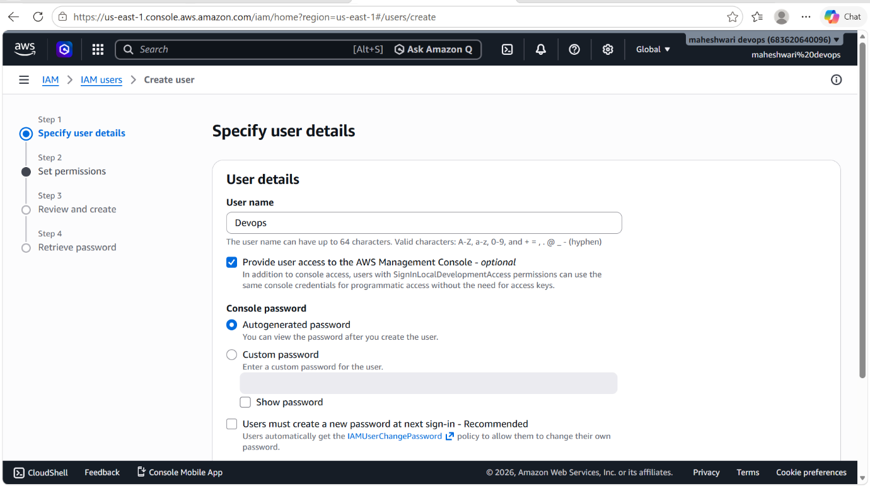

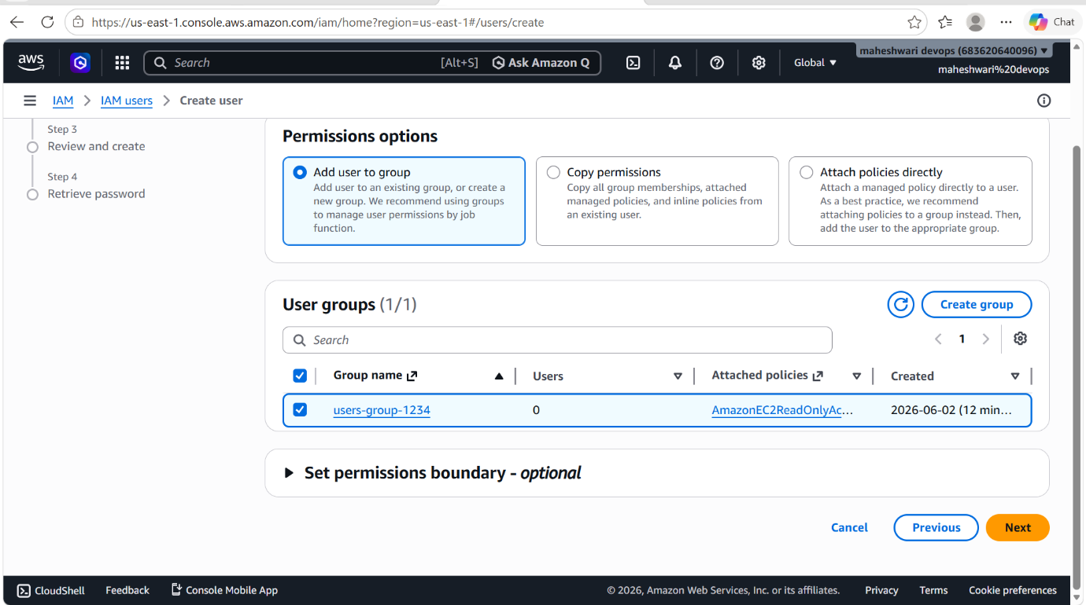

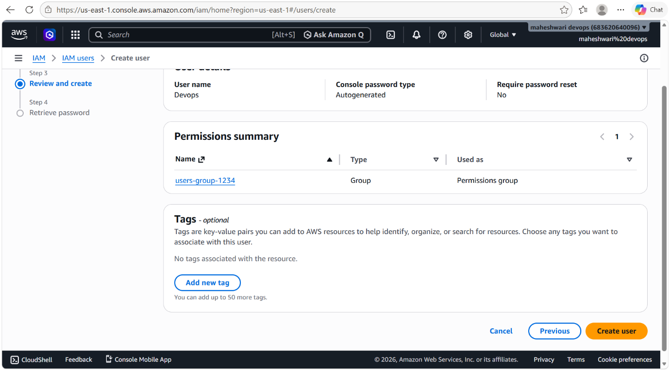

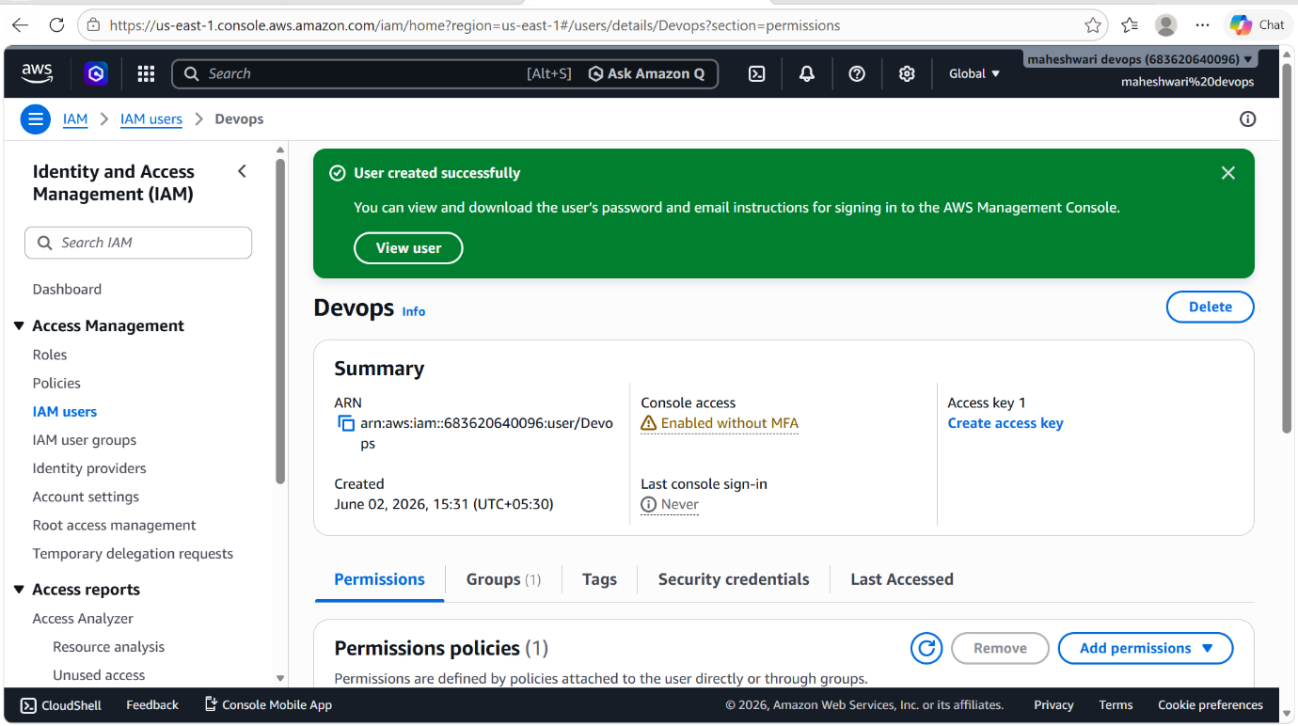

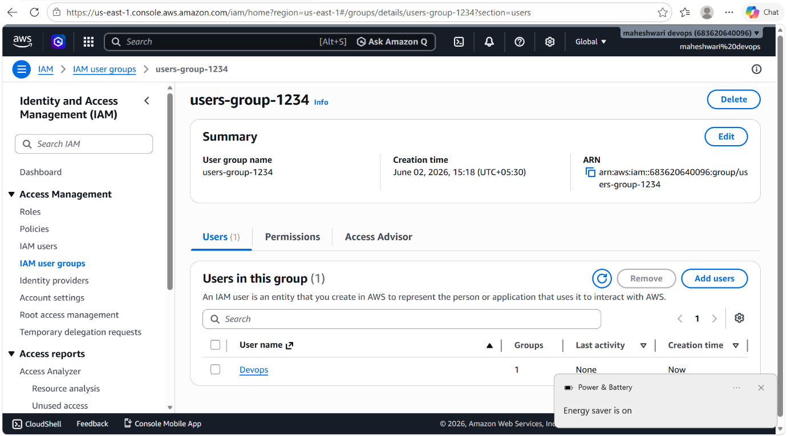

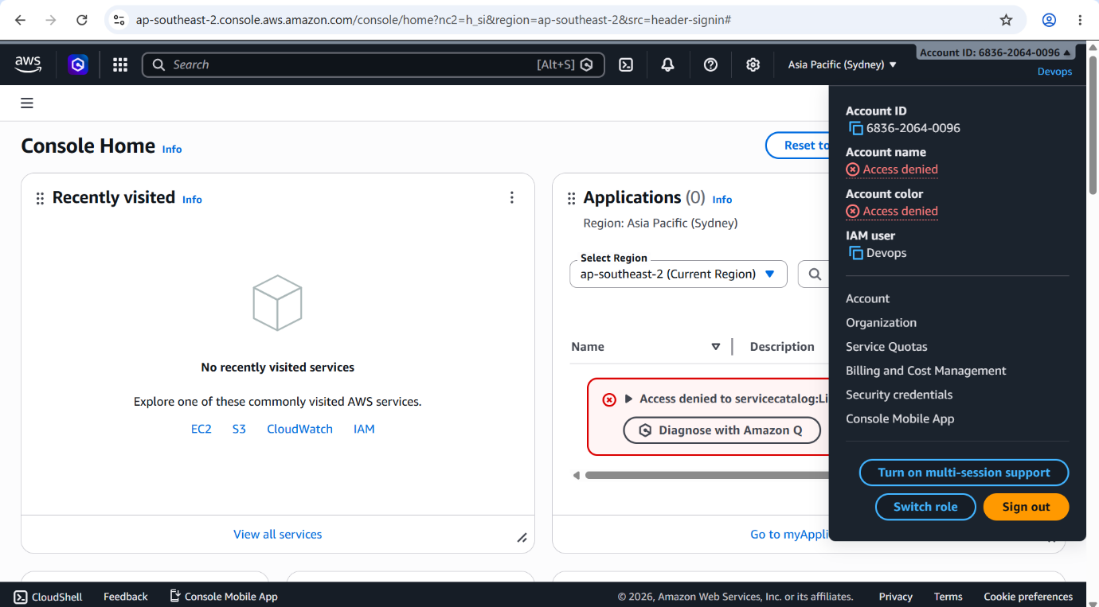

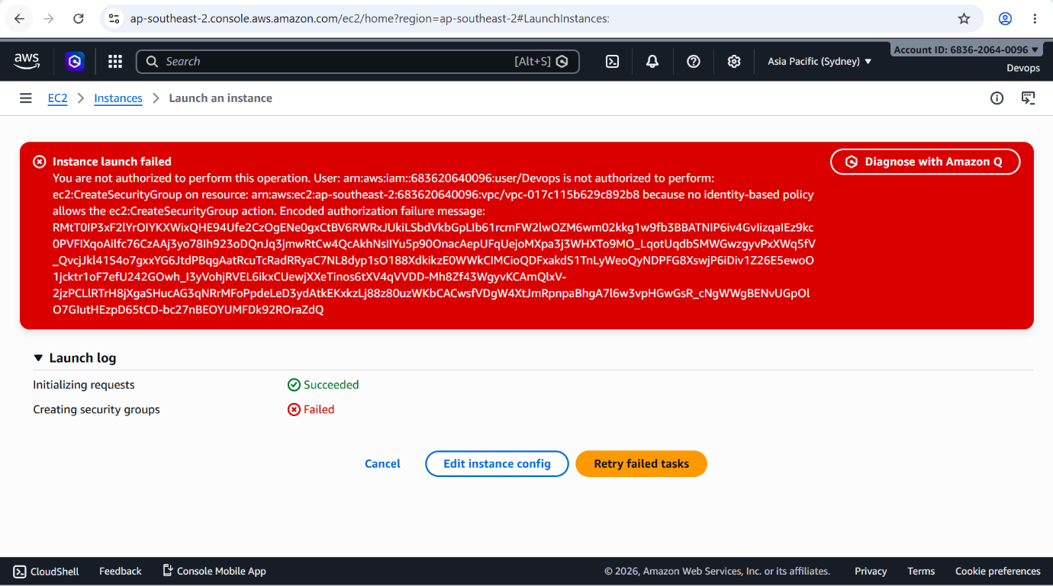

4. Write a bash script to create an IAM user with VPC full access.

PURPOSE: The purpose is to automate the creation of an AWS IAM user and assign permissions for full management of Amazon VPC resources, ensuring consistency, efficiency, and reduced manual effort.

STEP BY STEP IMPLEMENTATION:
- In bash, configure the aws cli by aws configure command.
- Then after configurations, create a bash file to write a script to create a user with VPC full access.
- Then change the permission of that .sh file.
- Then verify the user is created or not in AWS console.

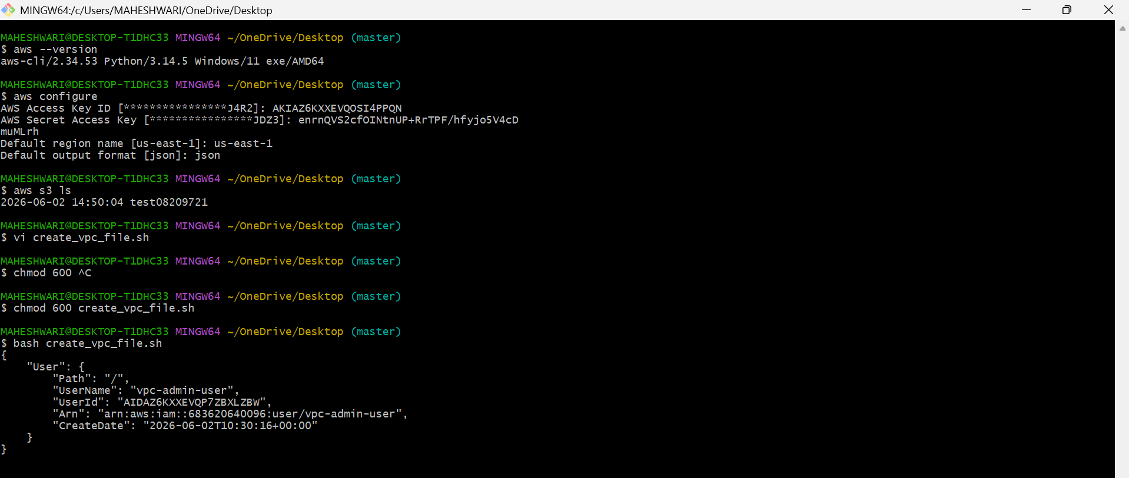

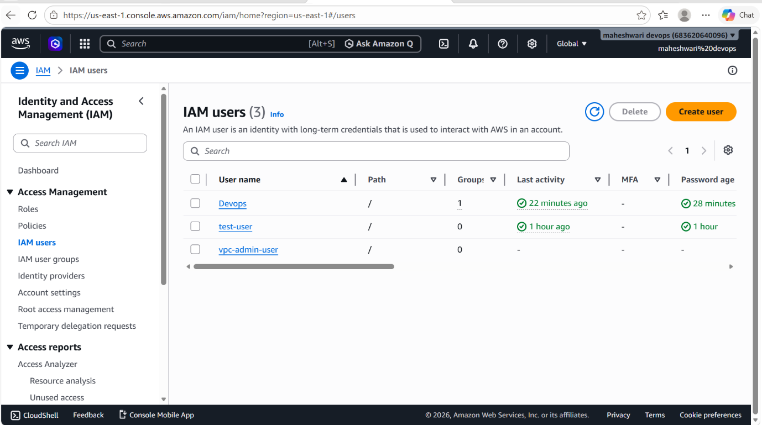

5. Create an IAM policy to allow EC2 access for a specific user in specific regions only.

PURPOSE: The purpose is to enforce region-based access control by allowing a specific IAM user to access and manage Amazon EC2 resources only in designated AWS regions, while restricting access to all other regions.

OBJECTIVE: The objective is to create and apply an IAM policy that restricts a specific user’s Amazon EC2 access to designated AWS regions, ensuring secure, compliant and controlled resource management.

STEP BY STEP IMPLEMENTATION:
- Create a custom policy.
- Open AWS Identity and Access Management (IAM).
- Navigate the policies -> create policy.
- Select the JSON tab
- Click NEXT and provide a policy name
- Create the policy
- Go to users and select the target user
- Choose add permissions -> Attach policies directly.
- Select created policies and attach that policy to that user.

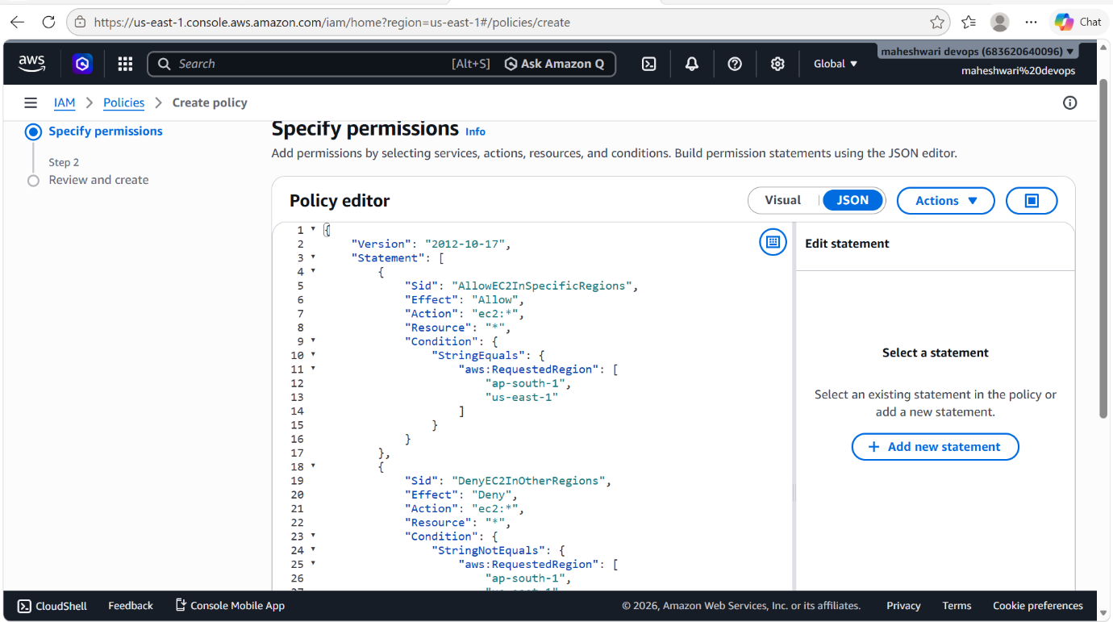

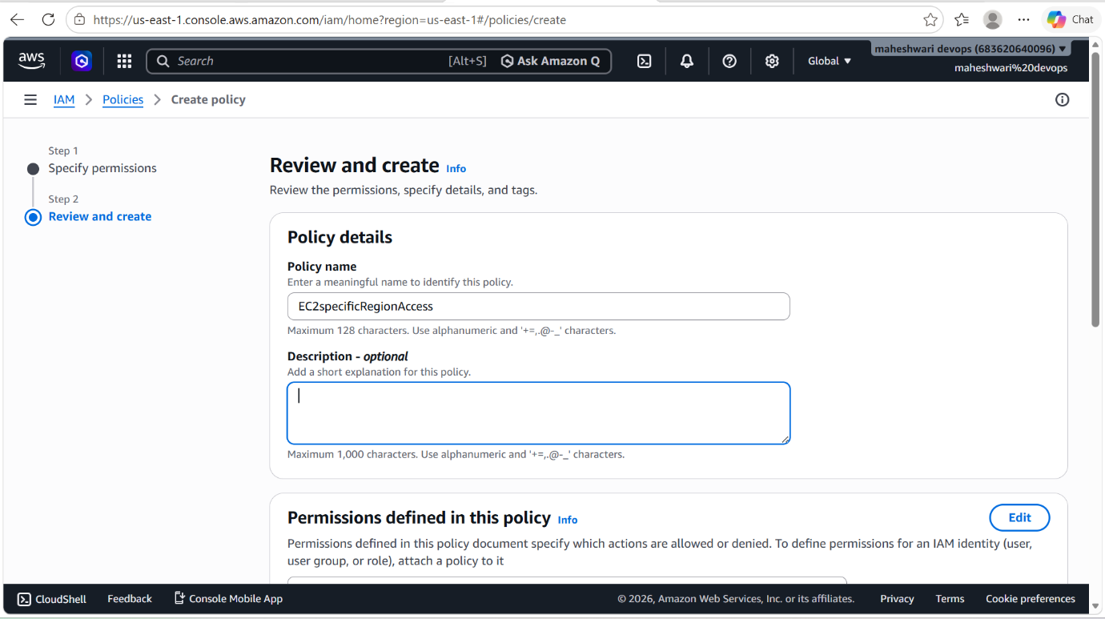

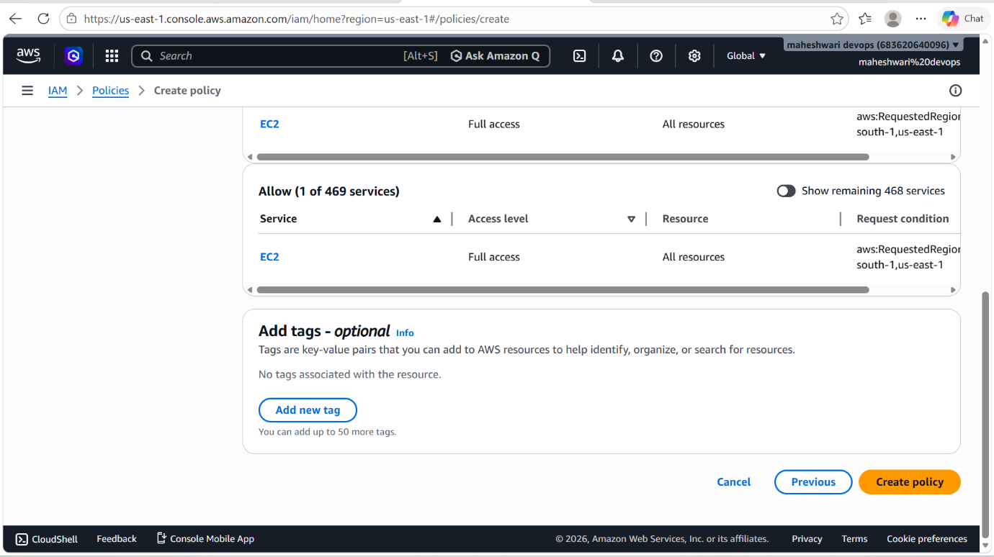

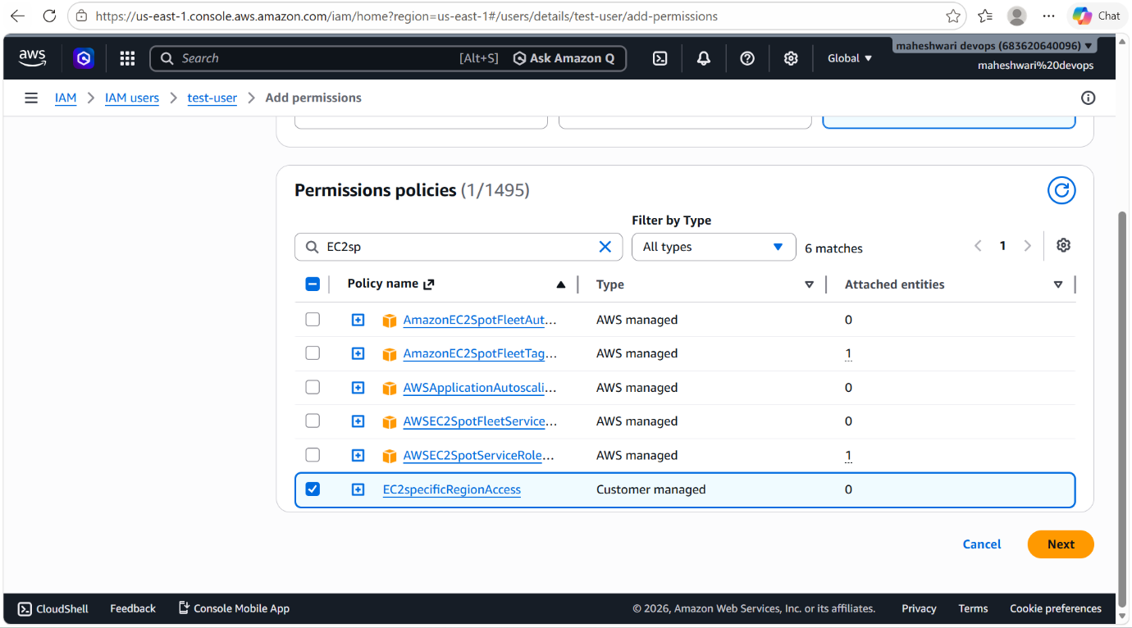

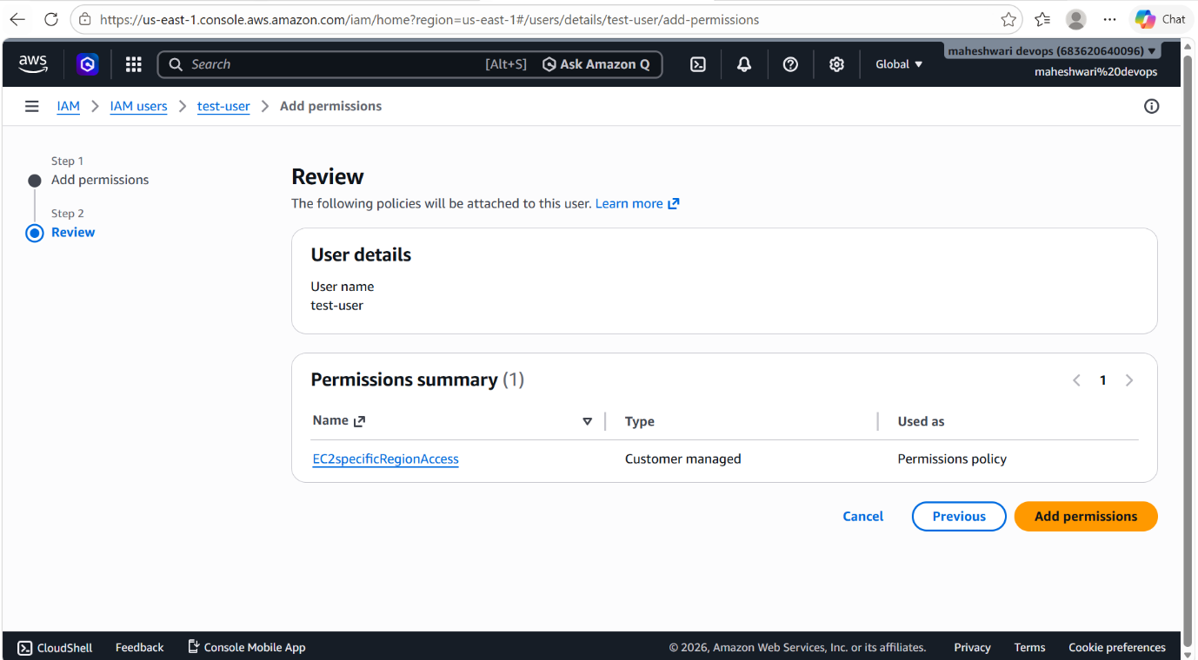

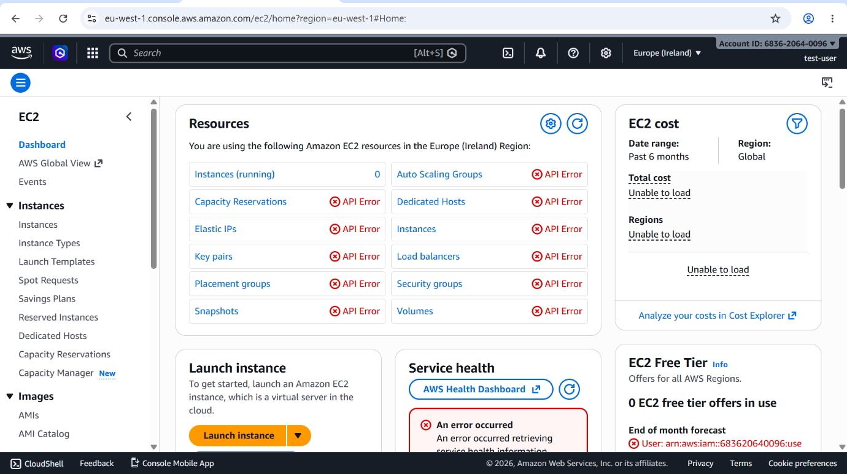

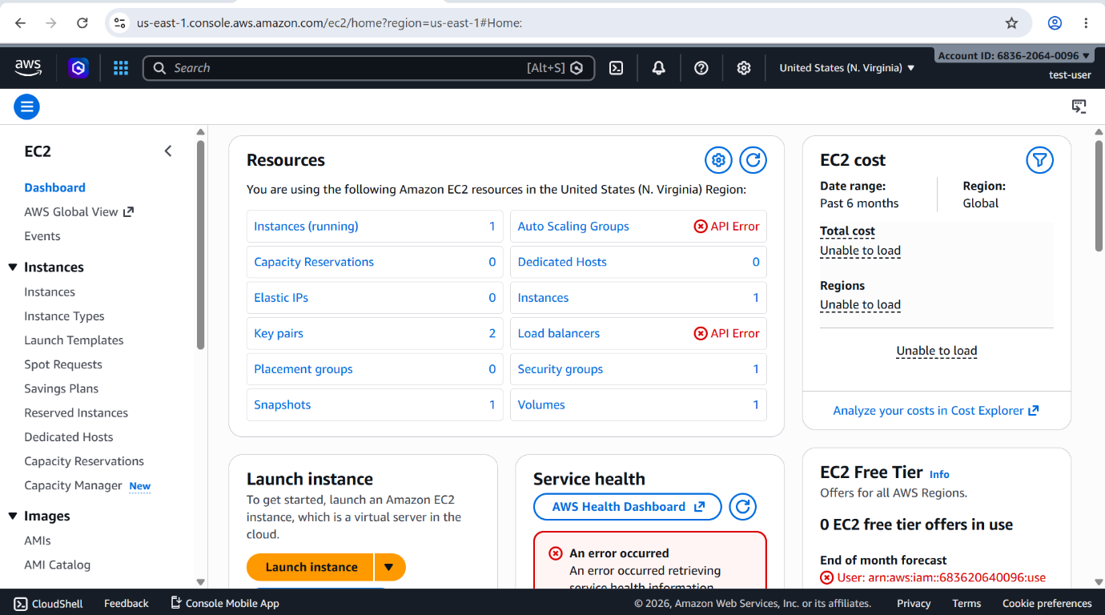

6. We have two accounts: Account A and Account B. Account A user should access an S3 bucket in Account B.

PURPOSE: The purpose is to enable secure cross-account access so that a user in Account A can access data stored in an Amazon S3 bucket owned by Account B without sharing account credentials.

OBJECTIVE: The objective is to configure secure cross-account access so that a user in Account A can access and perform authorized operations on an Amazon S3 bucket located in Account B while maintaining proper security controls and ownership boundaries.

OUTCOME: A user in Account A can securely access and interact with the specified Amazon S3 bucket in Account B according to the defined permissions, while Account B maintains full ownership, control, and security of the bucket and its contents.

STEP BY STEP IMPLEMENTATION:
Step 1: Grant Permissions to the IAM User in Account A
- Attach an IAM policy to the user s3-user in Account A:

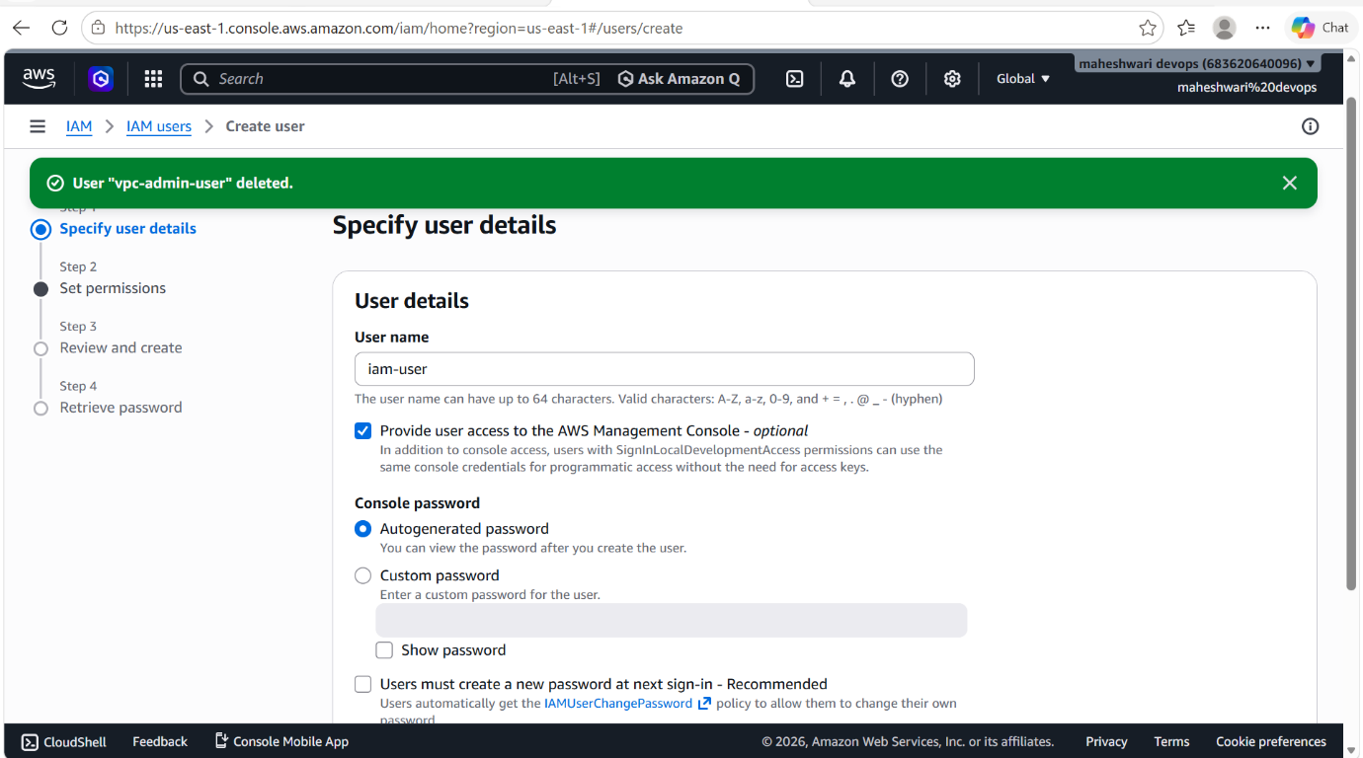

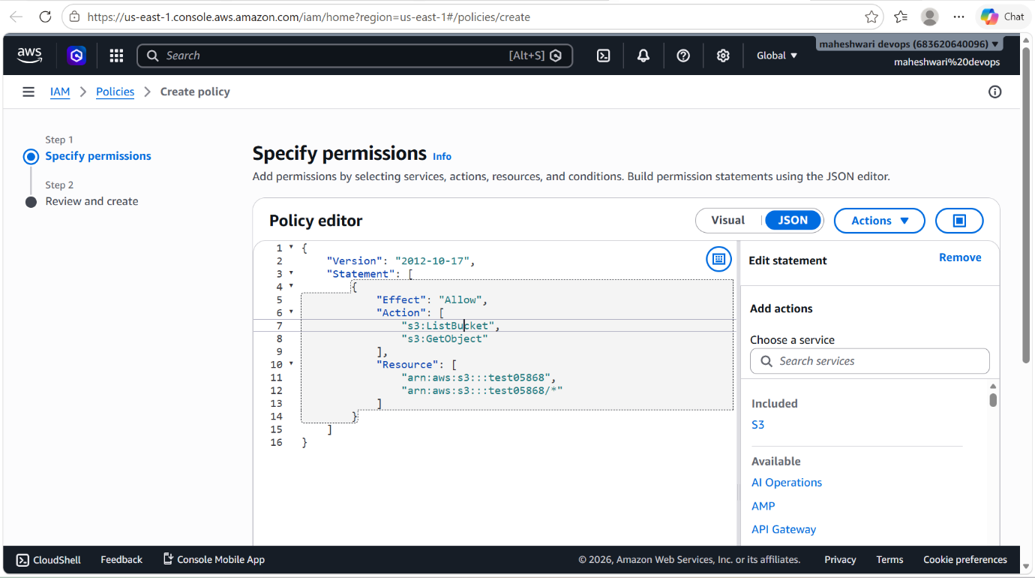

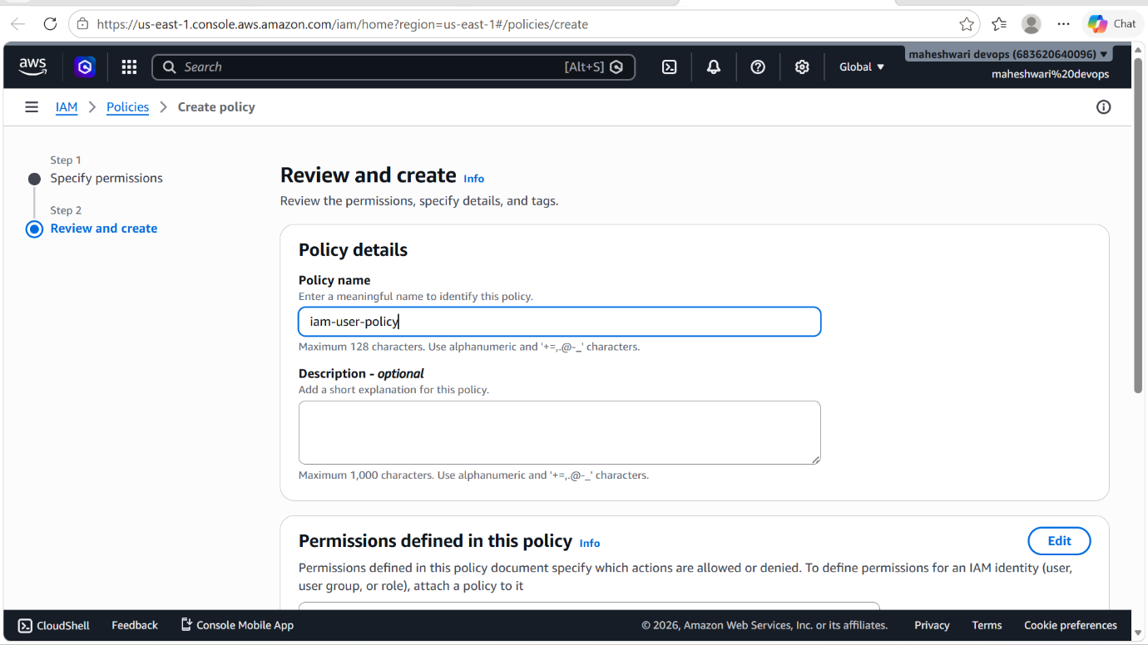

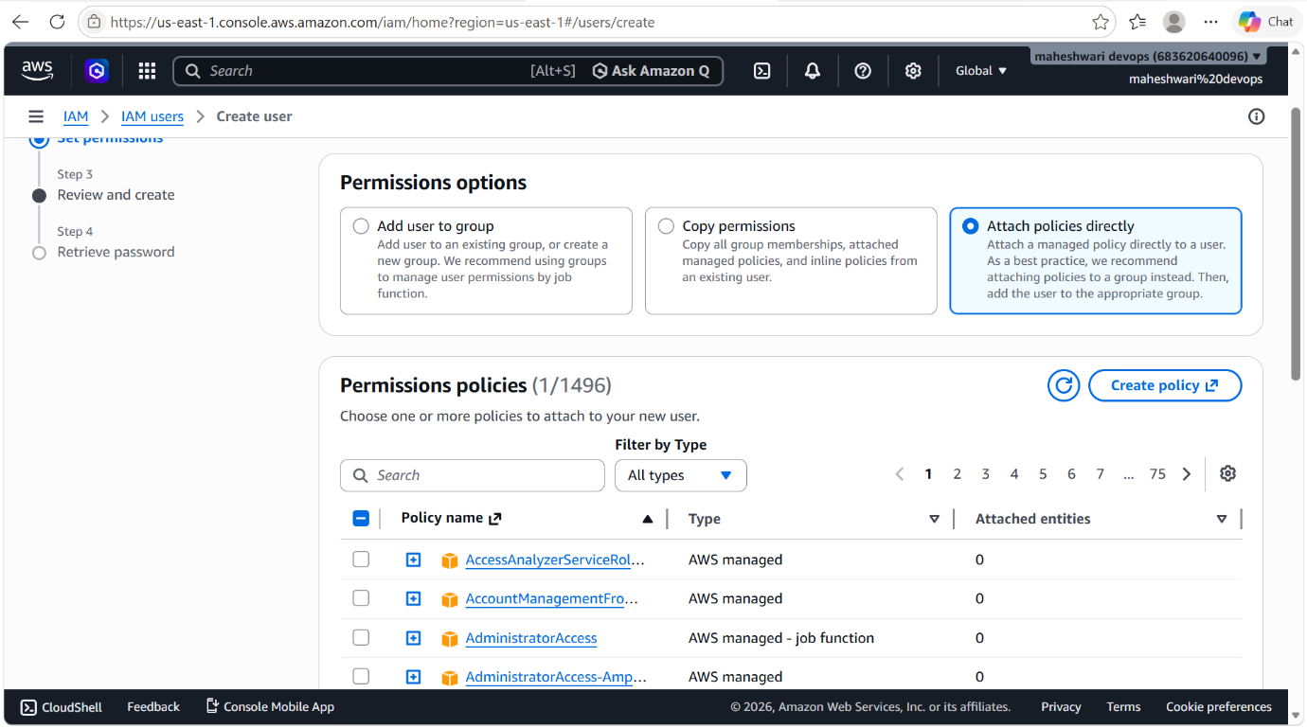

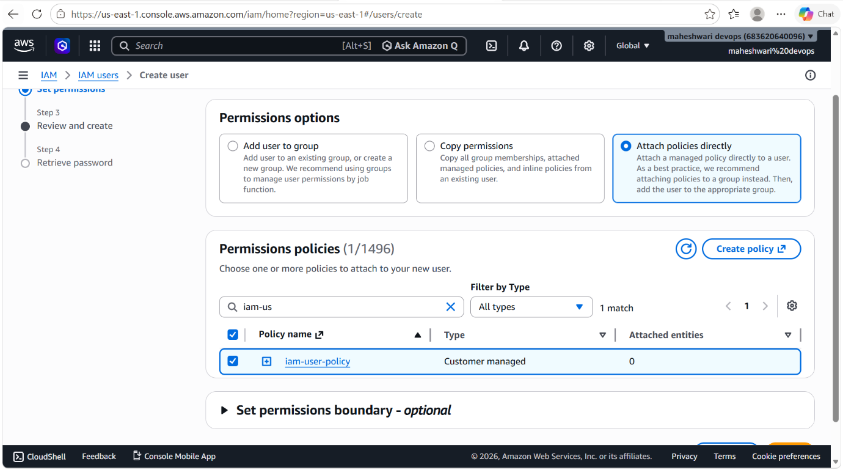

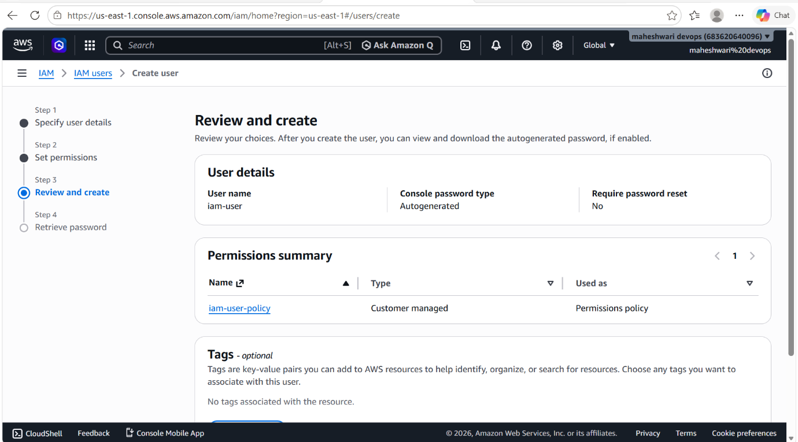

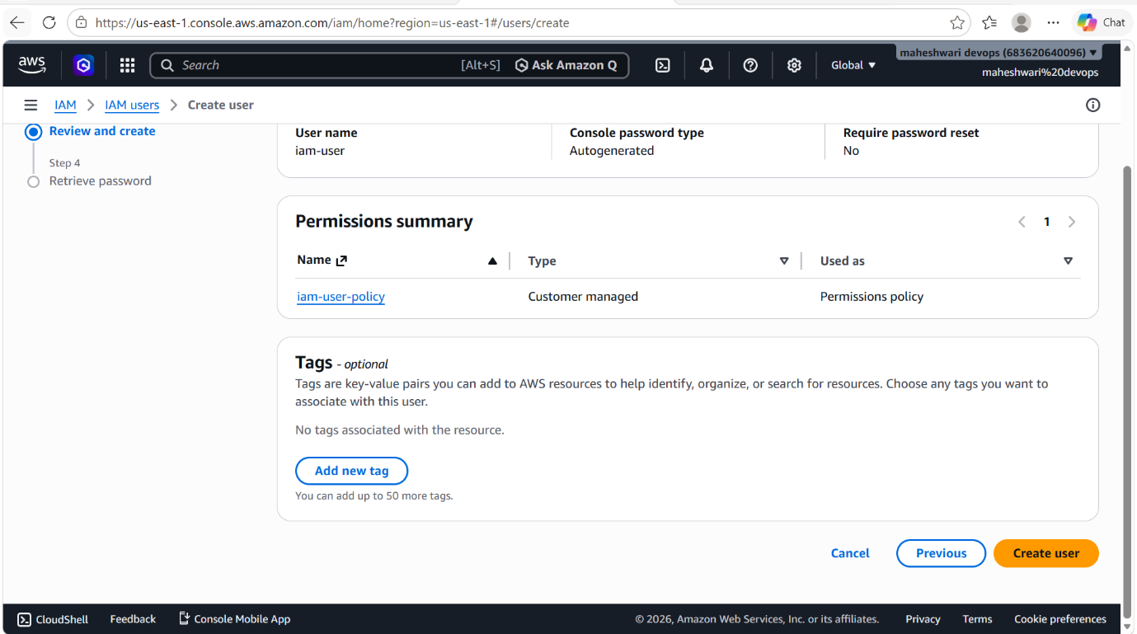

- Then share this IAM user ARN with the Account B.
- In Account B, will add a bucket with our IAM user ARN number.
- By this process, we will get the access of S3 bucket in account B.
- Access means we will have only read access.

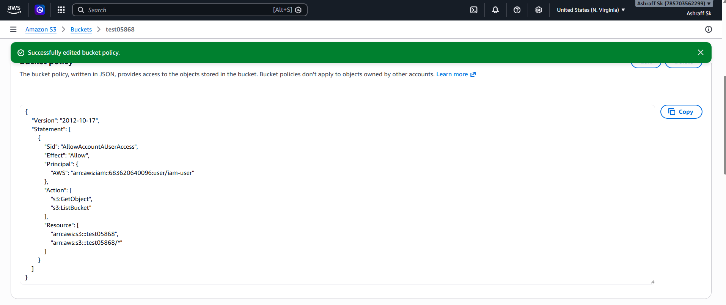

- Then in CLI we have to configure the IAM user that we have created for cross account access.
- Then execute the command -> aws s3 ls s3://<bucket-name>

